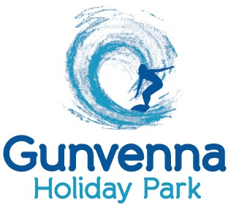
Swift Group
Cottingham
East Yorkshire
United Kingdom

3rd June 2015
To whom it may concern
RE: Gunvenna Holiday Park, Swift Moselle Lodge, Serial Number: 019068H
We placed an order with Surf Bay for the above Swift Moselle Lodge in October 2014 and were given an approximate build date end of April/May 2015.
We do accept that this is an approximate date and are normally undated closer to production, fast forwarding to the end of March 2015 I asked Surf Bay for a more definite build date for the Moselle Lodge. They told us that it should be built around the 13th April 2015 and as I kept in touch with Surf Bay this date moved more and more into May.
Upon realising the caravan would be built mid May I reminded Swift and Surf Bay that due to the limited road closure for the Royal Cornwall Show we would need the van delivered by mid May 2015, this was also confirmed by Duncan your Sales Director!
As we entered mid May I phoned the factory and was told the van had not been built yet and it would not be built until the end of the month contrary to what I had been told by Duncan and Surf Bay thus leaving us in a position that we could not update the customer of the delivery time of their new holiday home.
The communication from the factory of a definite built date is very poor.
We finally got an arranged pick up date with the factory of 20th May 2015 so we arranged our transport company to collect on the above date. When he arrived at the factory a member of staff on the gate would not let him in due his list not showing that the van was not built. After a phone call to Surf Bay to sort out this problem the driver was let in through the gate within minutes later I received another phone call from the driver saying that there was no one in the yard to help him yet after another phone call to Surf Bay a man appeared and said “I know which caravan your after” and went off to collect it! The caravan was brought into the yard and was loaded onto our driver’s lorry and made ready for departure.

Upon getting to the gate he was told he could not leave with this caravan as the chassis number did not match the chassis number on his records. He was asked to return to the yard and off load the home by which time all staff had left the factory and could not be given the correct home. As of which the home he should have been given was not ready!!!
Upon a phone call the next morning dispatch admitted the wrong home had been made ready due to a member of staff miss reading the chassis number.
I accept the fact the factory is on holiday and is running on limited staff but errors like this are unacceptable and costly. The knock on effect from the delays from this is that we have had to pay the Transport Company and Escort Company for the time of the first pick up.
Also due to the customer having to book holidays from work 6 months in advance we have had to put them up in alternative accommodation until the caravan has been sited, all connections and services connected.
This does not give a great impression of your Company!
We look forward to hearing from you and some way of compensation for this catalogue of errors.

Yours faithfully

Marcus Diamond
CC:
Duncan – Swift
Matt & Teresa – Surf Bay

Gunvenna Holiday Park, St. Minver, Wadebridge, Cornwall, PL27 6QN
Tel. 01208 862405
www.gunvenna.com

